Practice for Urology Khaled Othman  
Adamstraße 3, 13595 Berlin  
WhatsApp 01772398184 Tel.: 030 / 361 00 90 Fax: 030 / 30 12 44 91  
Mon to Fri from 10 AM – 3 PM Sat and Sun closed

--------------------------------------------------------------------------------------------------------------

1. 1. a: On the first day: After 6 hours, administer a pain suppository or syrup, then as needed.

b: Check the wound for bleeding every 30 minutes for 6 hours, without touching the dressing.

1. If the dressing falls off on the same day, apply wound cream, place a compress, and fasten the diaper tightly.
2. ATTENTION: From the next day onward, do not use dressings or compresses – only after consultation with the doctor!
3. Wound Care

4.1 24 hours after circumcision:  
A: Apply Bepanthen cream three times a day for 6 days.  
B: Loosely fasten the diaper to prevent sticking and skin drying.  
C: With each diaper change, pull the remaining skin 2–3 mm from the glans toward the abdomen (for 3 days) to prevent the skin from adhering to the glans.

4.2 48 hours after the procedure:  
Twice a day, gently clean the area by letting the child sit in a bowl of warm saltwater for 10–15 minutes.. Use 1 liter of lukewarm water with a pinch of salt. Rinse off wound coatings thoroughly and gently clean with cotton swabs.

Punkt 4.1

Punkt 4.2

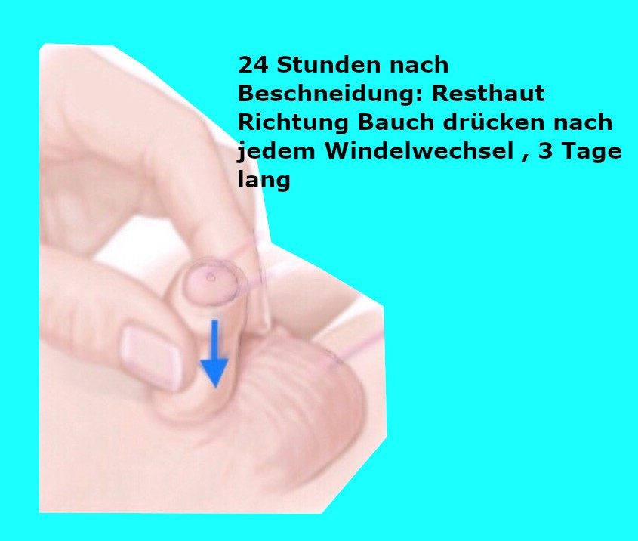 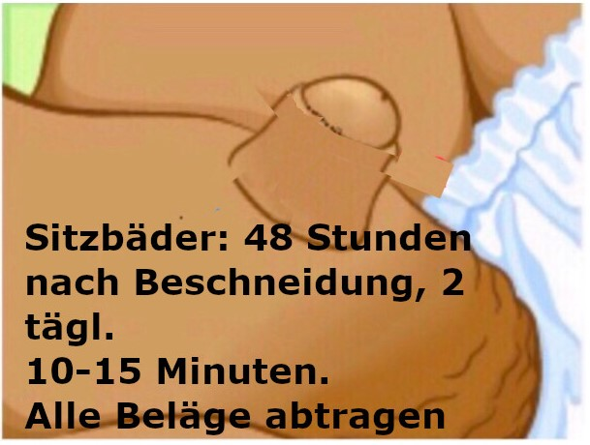 

1. Change wet diapers regularly, especially at night, to avoid fungal and bacterial infections.
2. 6. Starting from day 7 after circumcision, the child can be bathed.

7. Swelling of the wound edges and glans in the first few days up to about 2 weeks is normal to some extent. Bluish or reddish discoloration of the glans may also occur. If unsure, please contact the doctor.  
In emergencies such as bleeding, fever, or urinary retention, etc., please take the child to the emergency department of a hospital.  
  
In Berlin, for example:  
Charité, Augustenburger Platz 1, 13353 Berlin, Mittelallee 8